# HW9

# Wenhui Yang

# 2/26/2019

Exercise

sc <- read.csv(file.choose())

#1

mean(sc$eur_wage)

group1 <- aggregate(sc[,c("eur_wage","overall")], list(league=sc$league), mean)

group1

group1[which.max(group1$eur_wage),]

group1[which.max(group1$overall),]

[1] 11503.83

> group1 <- aggregate(sc[,c("eur_wage","overall")], list(league=sc$league), mean)

> group1[which.max(group1$eur_wage),]

league eur_wage overall

14 English Premier League 57840.98 72.40979

> group1[which.max(group1$overall),]

league eur_wage overall

41 Ukrainian Premier League 1000 74.70833

#2

rank <- order(sc$eur_value,decreasing = TRUE)

group2 <- aggregate(sc[,"eur_value"],by=list(club=sc$club),sum)

order <- group2[rank,]

order[1,]

> order[1,]

club x

471 Real Madrid CF 828900000

#3

group3 <- aggregate(sc[,c("eur_wage","age"],list(age=sc$age),mean)

plot(group3)

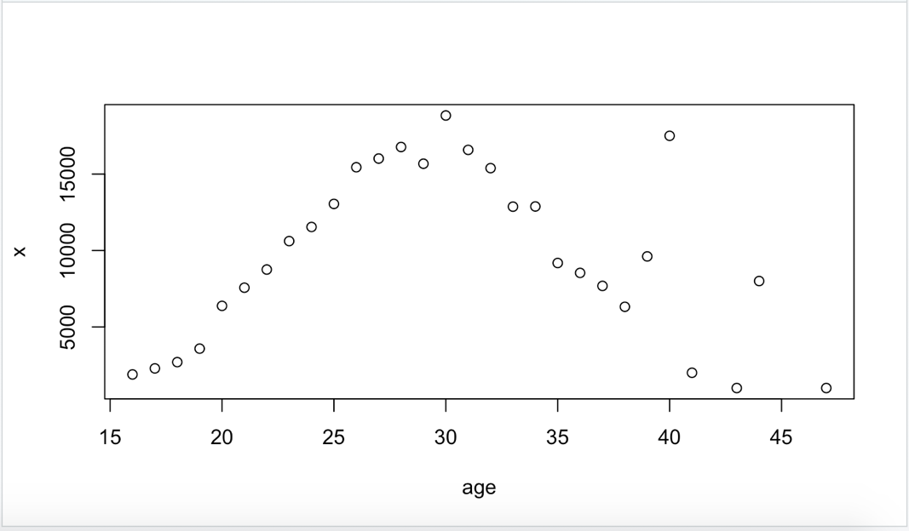

#4

sc$club <- as.factor(sc$club)

sc23 <- sc[(sc$age < 23),]

rank2 <- summary(sc23$club)

rank2[2]

> rank2[2]

Sevilla Atlético

28